**Master’s Thesis Proposal**

**Real-time Global Illumination using Voxel-based Ray-bundles**

**Che Sun**

**Advisor: Emmanuel Agu**

**Department of Computer Science**

**Worcester Polytechnic Institute**

**Abstract**

Real-time global illumination has gained more and more interests in recent years due to the rapid evolvement of GPU computing power. Some approaches have been developed to try to simulate global illumination as accurate as possible by implementing robust ray-tracing algorithms using Shader Model 5 features of current GPUs. For example, bidirectional path tracing is employed to resolve the classic singularity issue of instant radiosity. While the rendering speed is acceptable for a certain level of scene complexity, maintaining high frame rates for arbitrary scenes is still a challenging work. In this thesis, we propose a novel hybrid rendering system that combines bidirectional path tracing and scene voxelization to accelerate virtual point light (VPL) visibility tests and global ray-bundles generation. Meanwhile, we show that caustic maps can be integrated into the system easily as well.

Keywords: real-time global illumination, instant radiosity, global ray-bundles, scene voxelization, caustic maps

**1 Introduction**

Global illumination is an important lighting effect that simulates light propagation behavior in 3D space. It increases fidelity of computer generated images dramatically and thus has been an active research area in the field of image synthesis. Since the formal introduction of light transport equation [Kajiya 1986], many CPU-based off-line algorithms have been invented to solve it. While these techniques generate physically correct images, the speed of creating them are usually slow. Figure 1 shows images generated by PBRT, which is a CPU-based global illumination rendering system.

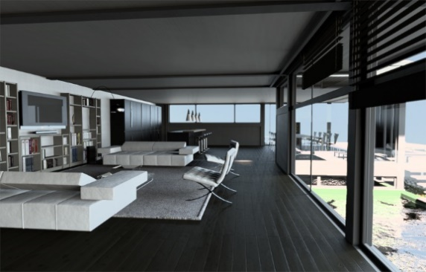 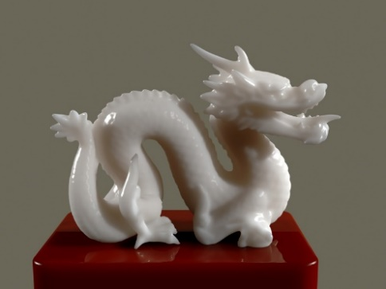

**Figure 1.** **Image courtesy of PBRT. Left: Modern villa scene by Florent Boyer. Right: Jade Dragon by Rui Wang.**

In order to implement global illumination for real-time applications such as video games, several approaches are introduced. One class of these approaches is called many-light based method, derived from [Keller 1997]. It provides a simple lighting computation framework that transforms the problem of solving lighting transport equation to the calculation of the direct illumination from many virtual light sources. The key observation is that general light transport problem can be approximated by generating a set of virtual light sources and doing direct illumination from them. This makes it a hardware-friendly algorithm which could be implemented on modern GPUs easily.

Many-light method is a biased method. While bias could be reduced by increasing the number of virtual light sources, frame rates will suffer if too many virtual light sources are generated and used for rendering. Most existing many-light based real-time approaches use shadow maps to do the visibility tests for indirect illumination calculation, which is currently the main bottle neck of them.

General real-time many-light methods also suffer from a singularity issue caused by failure of the sampling strategy at corners of scene geometry, where the distance between shading point and virtual light source is too close. One way of resolving this problem is clamping, which leads to incorrect rendering result. [Tokuyoshi 2012] introduces a better solution using bidirectional path tracing on GPU. They combine the many-light method with global ray-bundles method to construct a lighting path from both the virtual light source and the camera. Thus the overall rendering quality is improved. However, using global ray-bundles further increases the burden, because additional scene rendering task must be issued to create a ray-bundles for each virtual light source.

Another class of real-time global illumination methods make use of so called “voxel” to discretize to original scene representation. There are several advantages using scene voxelization: First, it is a geometry-independent scene description and some fast scene voxelization methods have been developed [Thiedemann et al. 2011] [Crassin 2011]. Second, ray-geometry intersection and visibility tests can be performed very fast on such data structure. Third, high quality anti-aliasing techniques can be implemented using voxelization as well [Crassin 2011].

In this thesis, we introduce a hybrid real-time global illumination system which combines the many-light method, global ray-bundles and scene voxelization together. By doing so, good rendering quality and speed could be achieved at the same time. We will replace the expensive VPL shadow maps generation task with a fast scene voxelization technique. Furthermore, we will use this voxelized scene description to generate imperfect global ray-bundles. Here, we call them voxel-based ray-bundles. This task should be much faster than the original method in [Tokuyoshi 2012]. Afterwards, we will implement an improved version of caustics maps using GPU concurrent link list [Yang 2010]. Integration of this technique into our system shall be simple since the system will be designed and implemented fully base on Shader Model 5 features.

**2 Related Work**

Instant Radiosity [Keller 1997] is a theoretical correct and hardware-friendly algorithm that solves the light transport equation [Kajiya 1986] efficiently. It supports fully dynamic scenes very well, which is important for interactive applications such as video games. General naive method creates many virtual point lights (VPL) in each rendering frame by sampling the scene description and then uses shadow maps to do the visibility tests when shading a fragment. Although intuitive and simple to implement, this method will hurt the frame rates a lot since VPL shadow maps creation requires sampling the scene description many times (usually 100 -1000). Many methods are developed to address this problem. Reflective shadow maps [Dachsbacher and Stamminger 2005] captures scene surface points visible to light sources efficiently but ignores visibility test for VPLs. [Segovia 2006] uses interleaved sampling [Keller and Heidrich 2001] to reduce the number of VPLs needed for each pixel being shaded. [Lane et al 2007] maintains a set of VPLs and regenerate a subset of them incrementally to reduce the overhead of VPL shadow map regeneration. [Ritschel et al. 2008] employs point-based rendering for the VPL shadow maps. The key idea is that instead of using original scene polygon, they use a set of point samples for the primitive rasterization process, which is much faster than the original polygon primitive rasterization. While using few VPLs is desirable, it leads to downsampling issues such as flickering especially when part of the scene is animated. To address this issue, [Knecht 2009] exploits temporal coherence [Nehab et al. 2007] to filter out high frequency signals between consecutive frames. Figure 2 shows a couple of methods mentioned above.

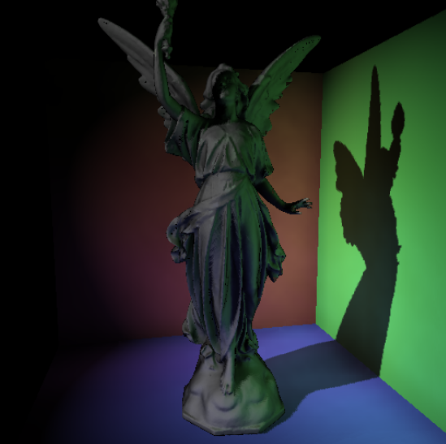 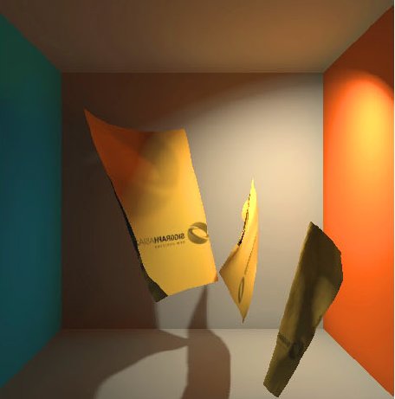 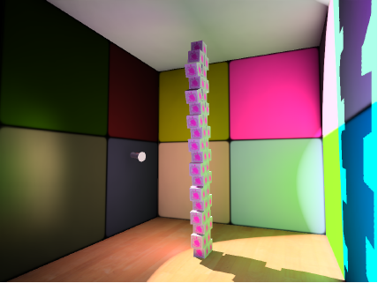

**Figure 2. Image courtesy of [Dachsbacher and Stamminger 2005], [Ritschel et al. 2008] and [Knecht 2009].**

**Left: Reflective Shadow Maps. Middle: Imperfect Shadow Maps for Efficient Computation of Indirect Illumination. Right: Real-Time Global Illumination Using Temporal Coherence.**

To improve the rendering quality, [Tokuyoshi 2012] changes the sampling strategy of VPL to bidirectional path tracing [Lafortune and Willems 1993; Veach and Guibas 1994]. This algorithm is known to be robust and resolves the failure of VPL sampling strategy successfully. They implement the algorithm on Shader Model 5 featured GPU by using global ray-bundles [Sbert 1996] and GPU concurrent link list [Yang 2010] to constructs a shading path from both a VPL and the viewing camera. Figure 3 shows their results.

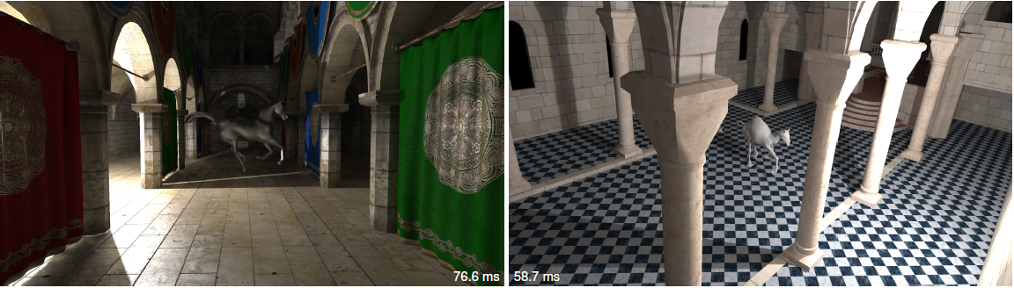

**Figure 3.** **Image courtesy of [Tokuyoshi 2012]. Real-time Bidirectional Path Tracing using VPLs and global ray-bundles.**

However, global ray-bundles introduces additional burdens, since every time a VPL is used, they also have to rasterize the scene polygon again in order to create a global ray-bundles along a sphere-unified random direction.

Voxel-based methods discretize the scene description and store discretized data in 3D grid cells. An outstanding feature of it is that scene voxelization is extremely fast (usually several million-seconds on current commodity GPUs). [Thiedemann et al. 2011] completes voxelization task from atlas textures by using per-vertex texture coordinates. Texture coordinates are used to index into texture atlas, which records world positions for each scene geometry to be voxelized. Thus this method needs artist-assisted texture coordinate assignment work and additional texture memory budget on GPU. Figure 4 shows their result.

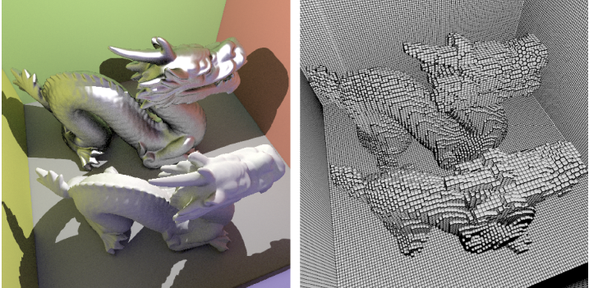

**Figure 4.** **Image courtesy of [Thiedemann et al. 2011]. Left: Voxel-based Global Illumination. Right: Visualization of scene voxelization.**

A drawback of using regular grid for voxelization is the high consumption of GPU memory. To solve this problem, [Crassin 2011] develops a sparse voxel octree (SVO) based data structure and uses it for their high quality global illumination rendering: they employ a pre-filtering process to filter the geometric data in a bottom-up fashion. The resulting hierarchical octree structure is then used for their voxel cone tracing. Figure 5 shows their result.

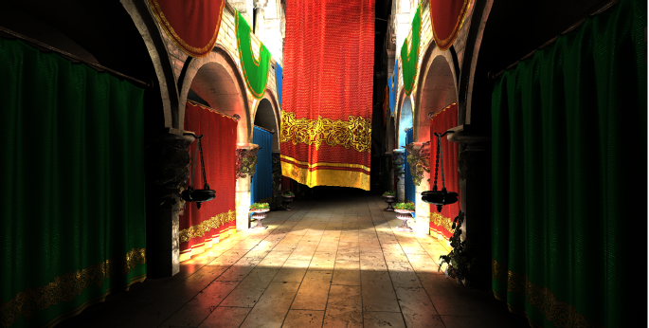

**Figure 5.** **Image courtesy of [Crassin 2011]. Interactive Indirect Illumination Using Voxel Cone Tracing.**

Caustics is another important lighting phenomenon that have gained much attention in the field of real-time rendering in recent years. [Shah et al. 2007] proposes Caustics Mapping, a technique simulates caustics in image space. The method consists of three steps: first, photon buffer is created from light’s view. Second, caustic map is generated by splitting points in photon buffer. Finally, caustic map is used for caustics rendering. Traditionally, the first step involves a two-pass rendering of the refractor geometry which leads to inefficiency. Moreover, to ensure good caustics quality, more photons have to be used. This is the main bottle neck of the algorithm. [Wyman and Nichols 2009] introduced adaptive caustic maps to reduce the cost of caustic map generation. The key idea is using a lazy algorithm that refines a coarse level buffer base on need (Add more photons where refractors exist). Figure 6 shows an image of adaptive caustic maps.

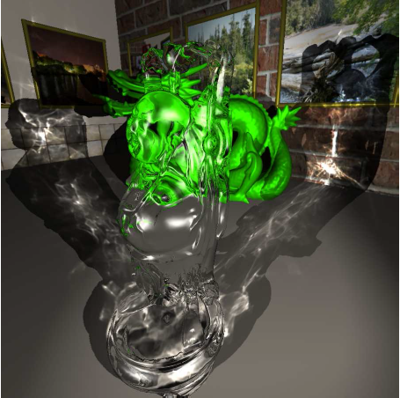

**Figure 6. Image courtesy of [Wyman and Nichols 2009]. Adaptive Caustic Maps.**

**3 Proposed Work**

We propose employing many-light, global ray-bundles and scene voxelization methods together to implement a robust and efficient real-time global illumination rendering system. Our novel rendering system shall be implemented fully based on shader model 5 features of commodity GPUs. Meanwhile, we will integrate an improved version of caustic maps technique into the system.

We will work on the following contributions:

* A voxel-based VPL visibility test system which replaces the current shadow map based visibility test system used by many-light methods.
* A voxel-based global ray-bundles system which accelerates global ray-bundles generation.
* An improved caustic maps method using GPU concurrent link list.

**4 Research Schedule**

**January – April 2014**

Theory study:

Spherical harmonics, Light Propagation Volume, Reflective Shadow Maps, SSDO, Instant Radiosity, Many-light methods.

API study:

Learn OpenGL shader programming.

Programming task:

Implement SSDO.

**May – August 2014**

Theory study:

Real-time bidirectional ray tracing via rasterization, GPU concurrent link list technique, Global ray-bundles, Imperfect Shadow Maps, Incremental Instant Radiosity, Interleaved Sampling.

API study:

Learn OpenCL and OpenGL compute shader programming.

Programming task:

Implement Reflective Shadow Maps.

Implement rendering framework to support multi-pass rendering.

Implement GPU concurrent link list.

Implement global ray-bundles.

**September – December 2014**

Theory study:

Real-time voxelization, Temporal Coherence, Paraboloid Shadow Map, Caustic Maps.

API study:

OpenGL geometry and tessellation shader programming.

Programming task:

Implement VPL demo.

Implement voxelization demo.

Combine VPL and voxelization together, implement voxel-based VPL visibility test.

**January – March 2015**

Programming task:

Implement voxel-based global ray-bundles.

Implement improved caustic maps.

Integrate caustic maps into the rendering system.

**April – May 2015**

Thesis writing, presentation and submission.

**References**

[Kajiya 1986] Kajiya, James T. "The rendering equation." *ACM Siggraph Computer Graphics*. Vol. 20. No. 4. ACM, 1986.

[Keller 1997] Keller, Alexander. "Instant radiosity." *Proceedings of the 24th annual conference on Computer graphics and interactive techniques*. ACM Press/Addison-Wesley Publishing Co., 1997.

[Tokuyoshi 2012] Tokuyoshi, Yusuke, and Shinji Ogaki. "Real-time bidirectional path tracing via rasterization." *Proceedings of the ACM SIGGRAPH Symposium on Interactive 3D Graphics and Games*. ACM, 2012.

[Thiedemann et al. 2011] Thiedemann, Sinje, et al. "Voxel-based global illumination." *Symposium on Interactive 3D Graphics and Games*. ACM, 2011.

[Crassin 2011] Crassin, Cyril, et al. "Interactive indirect illumination using voxel cone tracing." *Computer Graphics Forum*. Vol. 30. No. 7. Blackwell Publishing Ltd, 2011.

[Dachsbacher and Stamminger 2005] Dachsbacher, Carsten, and Marc Stamminger. "Reflective shadow maps." *Proceedings of the 2005 symposium on Interactive 3D graphics and games*. ACM, 2005.

[Segovia 2006] Segovia, Benjamin, et al. "Non-interleaved deferred shading of interleaved sample patterns." *SIGGRAPH/EUROGRAPHICS Conference On Graphics Hardware: Proceedings of the 21 st ACM SIGGRAPH/Eurographics symposium on Graphics hardware: Vienna, Austria*. Vol. 3. No. 04. 2006.

[Keller and Heidrich 2001] Keller, Alexander, and Wolfgang Heidrich. *Interleaved sampling*. Springer Vienna, 2001.

[Lane et al 2007] Laine, Samuli, et al. "Incremental instant radiosity for real-time indirect illumination." *Proceedings of the 18th Eurographics conference on Rendering Techniques*. Eurographics Association, 2007.

[Ritschel et al. 2008] Ritschel, Tobias, et al. "Imperfect shadow maps for efficient computation of indirect illumination." *ACM Transactions on Graphics (TOG)*. Vol. 27. No. 5. ACM, 2008.

[Knecht 2009] Knecht, Martin. *Real-time global illumination using temporal coherence*. na, 2009.

[Nehab et al. 2007] Nehab, Diego, et al. "Accelerating real-time shading with reverse reprojection caching." *Graphics hardware*. Vol. 41. 2007.

[Lafortune and Willems 1993] Lafortune, Eric P., and Yves D. Willems. "Bi-directional path tracing." *Proceedings of CompuGraphics*. Vol. 93. 1993.

[Veach and Guibas 1994] Veach, Eric, and Leonidas Guibas. "Bidirectional estimators for light transport." *Photorealistic Rendering Techniques*. Springer Berlin Heidelberg, 1995. 145-167.

[Sbert 1996] Sbert, Mateu, and Xavier Pueyo i Sàndez. *The Use of global random directions to compute radiosity: global Montecarlo techniques*. 1996.

[Yang 2010] Yang, Jason C., et al. "Real‐Time Concurrent Linked List Construction on the GPU." *Computer Graphics Forum*. Vol. 29. No. 4. Blackwell Publishing Ltd, 2010.

[Shah et al. 2007] Shah, Musawir A., Jaakko Konttinen, and Sumanta Pattanaik. "Caustics mapping: An image-space technique for real-time caustics." *Visualization and Computer Graphics, IEEE Transactions on* 13.2 (2007): 272-280.

[Wyman and Nichols 2009] Wyman, Chris, and Greg Nichols. "Adaptive caustic maps using deferred shading." *Computer Graphics Forum*. Vol. 28. No. 2. Blackwell Publishing Ltd, 2009.